**FINAIRO**

**EXPORT UNDERTAKING**

**For TRADE FINANCE**

# Document Information

|  |  |
| --- | --- |
| **Document Name:** | **EXPORT UNDERTAKING**- V04 |
| **Document Identification:** | **EXPORT UNDERTAKING** |

# Document Revision History

|  |  |  |  |  |  |
| --- | --- | --- | --- | --- | --- |
| **#** | **Ver** | **Rel. Date** | **Author** | **Reviewer** | **Reason for change** |
| 1 | 1.0 | 03-07-2022 | Arkadeep Bhattacharjee | Rajesh Yadav | Initial Release |
| 2 | 2.0 | 05-07-2022 | Arkadeep Bhattacharjee | Rajesh Yadav | -Activity description details added.  -Details added in Gap. |
| 3 | 3.0 | 19-07-2022 | Arkadeep Bhattacharjee | Bank Personals | Changes in Current practice, General Notes, Payment, Notice to Central Bank. |
| 4 | 4.0 | 11-05-2023 | Arkadeep Bhattacharjee | Swapnil Patil | Changes done as per Central Bank new Norms. |

# CONTENTS INDEX

Table of Contents

Document Information 2

Document Revision History 2

CONTENTS INDEX 3

1. A Export Undertaking Module 4

1. A1. Current Workflow of Export Undertaking: 4

1. A2. Finairo Working & Validations 5

1.A3. Accounting Entries (If any) 6

1) Issuing Posting: 6

2) Cancel Posting: 6

3) Closed: 7

4) Payment Posting: 7

5) Margin Confiscation: 8

1. A4. Validations 8

1) Validate the organizing of export undertaking with the blacklist: 8

2) Charges: 8

3) Issuance Validations: 8

4) Custom Certificate Registration: 8

5) Payment event. 8

1. A5. Gap: 9

B1) Create event (organize export undertaking) 9

B2) Custom clearance registration 10

B3) Payment: 11

B4) Amendment event: 12

B5) Cancel event: 12

B6) Close event. 13

B7) Export Undertaking Enquiry: 14

B8) Margin Confiscation: 14

B9) Alerting system: 14

B10) General notes: 15

1. A6. Field Changes/Requirements/Additional Fields 15

1. A7. Assumptions: 19

1. A8. RFP References 19

Disclosure: 19

# 1.A. Export Undertaking Module

# 1. A1. Current Workflow of Export Undertaking:

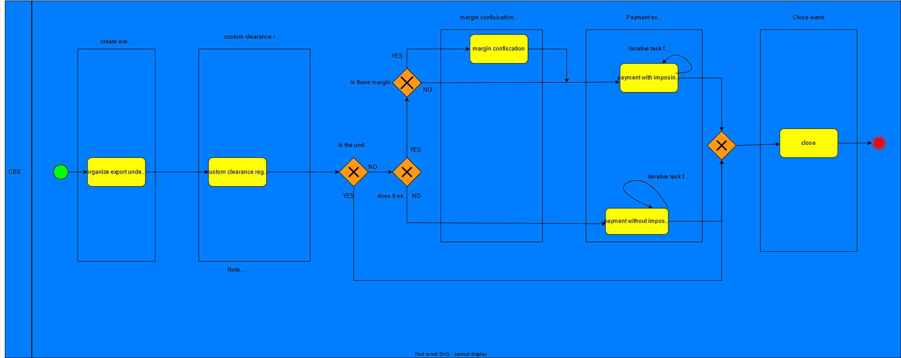

1. Both the exporter and importer agree to a documentary collection for payment in the sales agreement.
2. The information of the clean payment is received (in foreign currency) from the exchange company and the bank will send an informative letter to central bank the amount in foreign currency and exchange rate.
3. Central Bank will provide the Percentage rate.
4. Central Bank will send the amount in Local Currency to Commercial Bank.

# 1. A2. Finairo Working & Validations

1. **Export Undertaking Accounting Parameter** to be defined by admin. Here all the detailed accounts are to be provided, as per defined account the accounting process will happen.

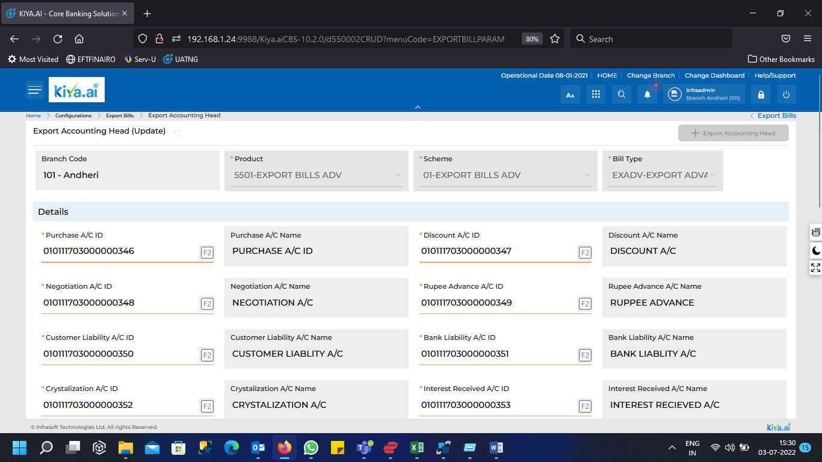

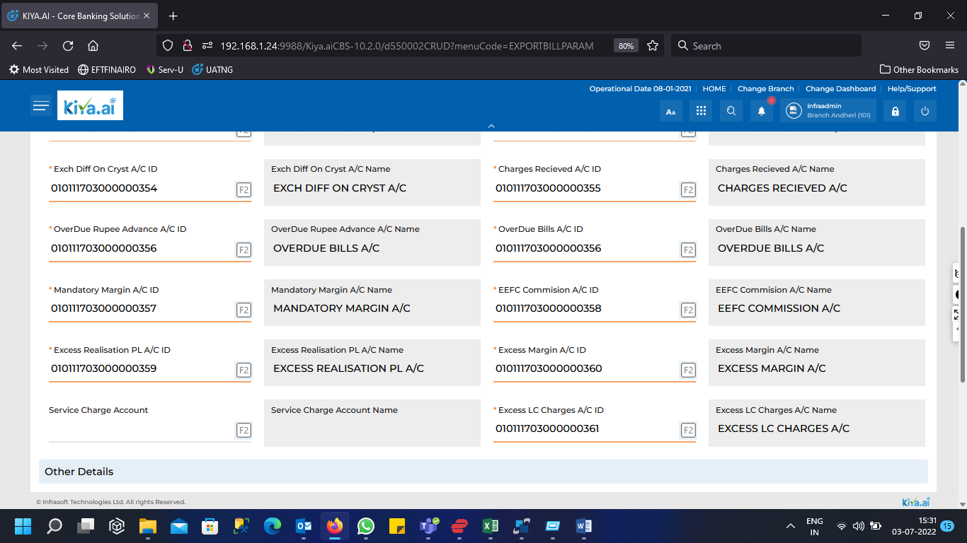

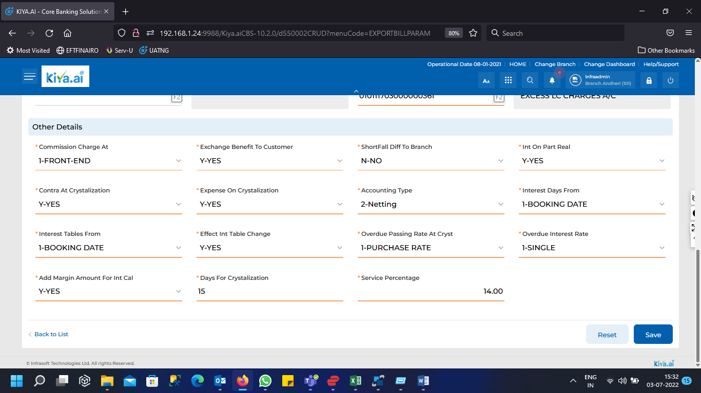

# 1.A3. Accounting Entries (If any)

## Issuing Posting:

DR: customer liability account (for the undertaking amount).

CR: bank liability account (for the undertaking amount).

DR: customer current account (for the margin amount).

CR: margin account (for the margin amount).

DR: customer current account (for commission amount).

CR: commission account (for commission amount).

If charges:

DR: customer current account (for each charge).

CR: charge account.

## Cancel Posting:

DR: Bank liability account (for the undertaking amount).

CR: Customer liability account (for the undertaking amount).

DR: margin account (for the margin amount).

CR: customer current account (for the margin amount).

If charges:

DR: customer current account.

CR: charge account.

## Closed:

DR: Bank liability account (for the remaining undertaking amount).

CR: Customer liability account (for the remaining undertaking amount).

DR: margin account (for the remaining margin amount).

CR: customer current account (for the remaining margin amount).

If charges:

DR: customer current account.

CR: charge account.

## Payment Posting:

DR: Bank liability account (prorated with the paid amount).

CR: Customer liability account (prorated with the paid amount).

DR: intermediary account (for the paid amount) (used to put the transferred amount from central bank temporary before credit the customer account).

CR: customer account (for the paid amount).

DR: margin account (prorated with the paid amount).

CR: customer current account (prorated with the paid amount).

DR: customer current account (for commission amount).

CR: commission account (for commission amount).

If charges:

DR: customer current account.

CR: charge account.

## Margin Confiscation:

DR: customer margin account.

CR: confiscation account (temporary account).

# 1. A4. Validations

## 1) Validate the organizing of export undertaking with the blacklist:

When the user wants to create an export undertaking for customer, this customer should be validated with the blacklist.

## 2) Charges:

These all charges that can be taken in export undertaking:

1. Stamp: 10000 SYP (flat).
2. Tax: (5%) * stamp, in SYP.
3. Military: 300 SYP (flat).
4. Rebuild commission: (10%) * (stamp + Military), in SYP.
5. Martyr stamp: 200 SYP (flat).

In all stages charges/commission to be collected as per defined in the charges master for export undertaking.

## 3) Issuance Validations:

1. Repayment Percentage (optional for the temporary type and mandatory for the final type).
2. Repayment amount (will calculated according to the filled repayment percentage).
3. Margin Percent & Amount & Currency (optional for all type of undertaking types).
4. Commission (percentage from the undertaking amount and should be configurable, currently: 0.004*undertaking amount).

## 4) Custom clearance Registration:

Maturity Date (this date will be starting from Exporting date).

## 5) Payment event.

1. Margin Percent & Amount & Currency (optional for all type of undertaking).
2. Commission (percentage from the undertaking amount and should be configurable, currently: 0.001*undertaking amount).
3. Fees details /delay days, fee amount, fee currency/ (fee amount is percentage from the unpaid amount, configurable, currently: 0.005*unpaid amount).

# 1. A5. Gap:

Following are the stages which to be followed in Export Undertaking

B1) Create event (organize export undertaking)

B2) Custom clearance registration

B3) Payment event.

B4) Amendment event.

B5) Cancel event.

B6) Close event.

B7) Export Undertaking Enquiry.

B8) Margin Confiscation.

B9) Alert Management.

B10) General notes.

## B1) Create event (organize export undertaking)

This is the initial stage when the bank receives the export undertaking from the applicant. Following are the fields which needed to be added to the screen.

**Fields to add:**

**The required fields:**

1. Auto Reference /Serial Unique number for Export Undertaking
2. Mail No(optional).
3. Mail Date(optional).
4. Decision number(optional).
5. Decision date(optional).
6. issue date (by default the sys date).
7. Exporter type/lookup/ (normal, legal)
8. Exporter Name (from CBS)/Text Field/(mandatory).
9. Exporter national id (from CBS)/number of 11 digits/(optional).
10. Exporter address (from CBS) /Text Field/(mandatory).
11. Commercial register number (from CBS) (optional).
12. Commercial register city (from CBS) (optional).
13. Agency number (can be added manually) (optional).
14. Importer name /Text Field/(mandatory).
15. Destination country /lookup/(mandatory).
16. Goods type /lookup/(mandatory).
17. Goods amount & currency. (mandatory).
18. Exchange rate/lookup/(mandatory).
19. Invoice number. (mandatory).
20. Invoice date. (mandatory).
21. Net weight. (optional).
22. Count (for the countable product) (optional).
23. Type (Temporary/Final) (mandatory).
24. Repayment Percentage (optional).
25. Repayment amount (will calculated according to the filled repayment percentage) (optional).
26. Margin Percent & Amount & Currency (optional: for temporary type no need for margin, the currency of reserved margin is local currency currently). (optional).
27. Commission (percentage from the undertaking amount and should be configurable, currently: 0.004*undertaking amount). (with the ability to edit it) (calculated automatically and optional)
28. Remark/note field. (optional).
29. Charges. (optional).

**Output Documents:**

Multiple documents can be provided to the applicant and beneficiary. According to certain formats which will be received from the bank.

**DMS:**

**Uploading docs to DMS is needed.**

## B2) Custom clearance registration

On this activity applicant brings a document from Customs and Bank register the Customer clearance Date.

**Fetch the following fields from the creation event (all fetched fields to be disabled).**

1. Auto Reference.
2. creation date.
3. Exporter Name.
4. Exporter national id.
5. Exporter address.
6. Commercial register number.
7. Commercial register city.
8. Agency number.
9. Importer name.
10. Destination country.
11. Goods type.
12. Goods amount & currency.
13. Exchange rate.
14. Invoice number.
15. Invoice date.
16. Net weight.
17. Count.
18. Type (Temporary/Final).
19. Repayment Percentage.
20. Repayment amount.
21. Margin Percent & Amount & Currency.

**in addition to filling out the new following fields:**

1. Exporting date(mandatory).
2. Maturity period (some of months and days) (mandatory).
3. Maturity Date (will be calculated automatically, Exporting Date + Maturity period) (mandatory).
4. Remark/note field(optional).
5. Exporting details (list of lines), each detail contains the following fields:
   * custom item/text field/ (optional).
   * goods type/look up/(optional).
   * count(optional).
   * Net weight(optional).
   * amount& currency(optional).
   * custom detail NO (optional).
   * custom detail Date (optional).
   * goods exporting date (optional).

**DMS:**

**Uploading docs to DMS is needed.**

## B3) Payment:

At this stage the amount to be collected. The following fields to be added for payment as mentioned.

**Fetch the following fields from create event (all these fields will be disabled):**

1. Auto Reference.
2. creation date.
3. Exporter Name.
4. Exporter national id.
5. Exporter address.
6. Commercial register number.
7. Commercial register city.
8. Agency number.
9. Importer name.
10. Destination country.
11. Goods type.
12. Goods amount & currency.
13. Exchange rate.
14. Invoice number.
15. Invoice date.
16. Net weight.
17. Count of items.
18. Type (Temporary/Final).
19. Repayment Percentage.
20. Repayment amount.
21. Margin Percent & Amount & Currency

**In addition to filling out following fields:**

1. Unpaid amount (will be calculated automatically).
2. Operation date (by default sys date).
3. Payment date (can be previous date, to enable the user to select the actual date of receiving the letter from the exchange company).
4. Normal exchanges rate/lookup/(mandatory) (with possibility to edit the rate value, to fit it with the exchange rate of the same date of receiving letter from exchange company (Payment date)).
5. Premium exchange rate/lookup/(mandatory) (with possibility to edit the rate value, to fit it with the exchange rate of the same date of receiving letter from exchange company (Payment date)).
6. Payment amount & currency (foreign currency) (mandatory).
7. Payment amount & currency in Arabic words (automatically filled).
8. Payment amount & currency (local currency) (automatically filled, (Normal exchanges rate+ Premium exchange rate) * payment amount in foreign currency= payment amount in local currency).
9. Commission (percentage from the undertaking amount and should be configurable, currently: 0.001*undertaking amount) (with the ability to edit it).
10. Fees details /delay days, fee amount, fee currency/

fee amount is percentage(configurable) from the unpaid amount for each delay day, currently: 0.005*unpaid amount*delay days, delay days is the period from maturity date to payment date, and this fee will be debited from the confiscated margin amount (in temporary account) by someone else out of export undertaking department.

1. Intermediary account (this account contains the local amount transferred from central bank).
2. Customer Cr account (customer current account).
3. Remark/note field.
4. Charges.

**DMS:** **uploading docs to DMS is needed.**

**Note:** for the case of partial payment, we must take the commission for only one time, at the first time of part payment.

## B4) Amendment event:

Fetch the field from creation event, with the ability to amend it.

In amendment event, do not change the amount or the maturity date of the export undertaking.

**No amendment event after custom clearance event.**

In addition to charges fields.

## B5) Cancel event:

This event cannot be applied after custom clearance event.

**The fields will be fetched from the organization event (all these fields will be disabled).**

1. Auto Reference.
2. creation date.
3. Exporter Name.
4. Exporter national id.
5. Exporter address.
6. Commercial register number.
7. Commercial register city.
8. Agency number.
9. Importer name.
10. Destination country.
11. Goods type.
12. Goods amount & currency.
13. Exchange rate.
14. Invoice number.
15. Invoice date.
16. Net weight.
17. Count of items.
18. Type (Temporary/Final).
19. Repayment Percentage.
20. Repayment amount.
21. Margin Percent & Amount & Currency.

**In addition to filling out the following fields:**

1. reason for cancellation field(optional).
2. Remark/note field(optional).
3. Charges(optional).

The status of this undertaking will be ‘CANCELED’.

## B6) Close event.

This event can be applied only after I pay the undertaking totally or if this undertaking is temporary (for temporary type no need to apply payment).

**The fields will be fetched from the organization event (all these fields will be disabled).**

1. Auto Reference.
2. creation date.
3. Exporter Name.
4. Exporter national id.
5. Exporter address.
6. Commercial register number.
7. Commercial register city.
8. Agency number.
9. Importer name.
10. Destination country.
11. Goods type.
12. Goods amount & currency.
13. Exchange rate.
14. Invoice number.
15. Invoice date.
16. Net weight.
17. Count of items.
18. Type (Temporary/Final).
19. Repayment Percentage.
20. Repayment amount.
21. Margin Percent & Amount & Currency.

In addition to filling out the new following fields:

1. Remark/note field(optional).
2. Charges(optional).

The status of this undertaking will be ‘CLOSED’.

**DMS:** **uploading docs to DMS is needed.**

## B7) Export Undertaking Enquiry:

The same logic in the other TF modules, the user should be able to search for specific undertaking, showing the events applied on this undertaking and filtering the results by the stage.

## B8) Margin Confiscation:

This event currently can be applied in one case only, when we reach the maturity date without payment, in this case after maturity date we have to confiscate the margin in special account (temporary account), until the customer comes again to pay.

When the customer pays, in this case the fee will be taken from the confiscated margin amount and revert the remaining margin to the customer current account.

This event in the foreseeable future may be applied in different cases, so it is preferred to have the ability to apply this event whenever the user wants.

**The procedure in this event:**

Transfer the margin amount from the customer margin account to another temporary account.

Remark field is needed also in this event.

## B9) Alerting system:

* Alert before 15 days (configurable value) from the maturity date.
* Alert for the undertaking that organized 15 days ago (configurable period) without custom clearance event.
* Alert for the unpaid export undertaking when reach the maturity date to remind the user to apply Margin confiscation.

## B10) General notes:

**View reports on demand:**

In this part the user will query some documents and reports according to some parameters (Bank to Provide Required Documents).

# 1. A6. Field Changes/Requirements/Additional Fields

## C1) Issuance screen

|  |  |
| --- | --- |
| Fields | Description |
| 1-      Auto Reference /Serial Unique number of Export Undertaking/ | Unique number of Export Undertaking |
| 2-      Mail No(optional). | Text Field |
| 3-      Mail Date(optional). | Date |
| 4-      Decision number. | Number |
| 5-      Decision date. | Date |
| 6-      creation date. | Date |
| 7-      Exporter Name (from CBS)/Text Field/ | Text Field |
| 8-      Exporter national id (from CBS)/number of 11 digits/ | Text Field |
| 9-      Exporter address (from CBS) /Text Field/. | Text Field (Fetched from Customer Master) |
| 10-   Commercial register number (from CBS). | Fetched from Customer Master |
| 11-   Commercial register city (from CBS) | Text Field |
| 12-   Agency number (can be added manually). | Number |
| 13-   Importer name /Text Field/. | Text Field |
| 14-   Destination country /lookup/. | Lookup |
| 15-   Goods type /lookup/. | Lookup |
| 16-   Goods amount & currency. | Float and Text Field |
| 17-   Exchange rate/lookup/. | Lookup |
| 18-   Invoice number. | Number |
| 19-   Invoice date. | Date |
| 20-   Net weight. | Float |
| 21-   Count (for the countable product). | Number |
| 22-   Type (Temporary/Final) | Lookup |
| 23-   Repayment Percentage (optional for the temporary type and mandatory for the final type). | Float |
| 24-   Repayment amount (will calculated according to the filled repayment percentage). | Float |
| 25-   Margin Percent & Amount & Currency (optional: for temporary type no need for margin). | Float & Float & Text |
| 26-   Commission (percentage from the undertaking amount and should be configurable, currently: 0.004*undertaking amount). | Float |
| 27-   Remark/note field. | Text |
| 28-   Charges. | Float |

## C2) Custom clearance registration

|  |  |
| --- | --- |
| Fields | Description |
| 1.       Exporting date. | Date |
| 2.       Maturity Date (this date will be starting from Exporting date). | Date |
| 3.       Remark/note field. | Text |
| 4.       Exporting details (list of lines), each detail contains the following fields: | Following Details to be add in Multilines |
| ·         custom item/text field/. | Text |
| ·         goods type/look up/ | Lookup |
| ·         count. | number |
| ·         Net weight. | Float |
| ·         amount& currency. | Float & Text |
| ·         custom detail NO. | number |
| ·         custom detail Date. | Date |
| goods exporting date | Date |

## C3) Payment

|  |  |
| --- | --- |
| Fields | Description |
| 1-      Unpaid amount. | Float |
| 2-      Operation date. | Date |
| 3-      Payment date. | Date |
| 4-      Payment amount & currency (foreign currency). | Float & Text |
| 5-      Payment amount & currency in Arabic words. | Text |
| 6-      Payment amount & currency (local currency). | Float & Text |
| 7-      Commission (percentage from the undertaking amount and should be configurable, currently: 0.001*undertaking amount). | Float |
| 8-      Fees details /delay days, fee amount, fee currency, DR account, CR account/ (fee amount is percentage from the unpaid amount, currently: 0.005*unpaid amount). | Float |
| 9-      Remark/note field. | Text |
| Charges | Float |

## C4) Cancel Event:

|  |  |
| --- | --- |
| Fields | Description |
| 1-      reason for cancellation field. | Text |
| 2-      Remark/note field. | Text |
| 3-      Charges. | Float |

## C5) Close

|  |  |
| --- | --- |
| Fields | Description |
| 1.       Remark/note field. | Text |
| 2. Charges | Float |

# 1. A7. Assumptions:

No Assumptions

# 1. A8. RFP References

|  |  |  |
| --- | --- | --- |
| **Sr no** | **RFP Reference** | **Point number** |
| 1 | *PART III-9 FUNCTIONAL SPECIFICATIONS EXPORT DOCUMENTARY COLLECTION* | 16 |
| 2 | *BRANCH MODULE (Part III -3) 7-13 Forex Operations* | 7 |

# Disclosure:

The RFP Part III and the proposal are the master document for the UAT related signoff.

This document can be used as a reference point for closure of UAT related pertaining to overall scope of Export Undertaking.